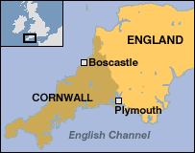
Fact-file
- North-West coast of Cornwall
- Downstream to mountain range Bodmin Moor
- 200.2 mm fell on 16th August within 4 hours
- Peak discharge between 5-6pm at 140 cumecs (m³/s)
- Located in the middle of a steep sided V-shaped Valley
- Downstream of the Jordan-Valency confluence
- 50 mm fell on Boscastle itself
- 3 metre high wall of water swept through the village

Causes
- Discharge overcame channel boundaries
- Already saturated ground meant the high intake from Bodmin Moor could only flood the above ground
- Steep-sided valley meant water level was exaggerated and more focused on one area
- Small Bridge meant build up of water and sediment blocking water

Impacts
- 120 people trapped
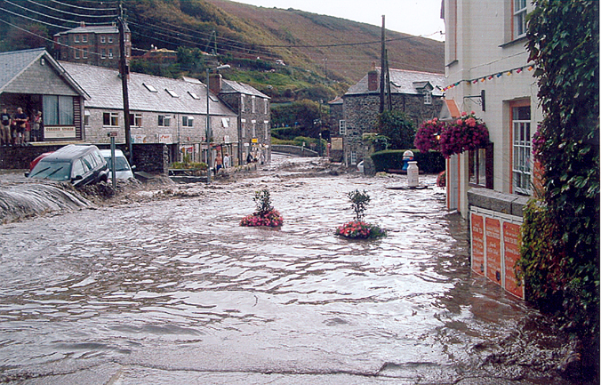
- Car park and two bridges destroyed
- Vehicles swept away – 30 ending up in the harbour
- Two shops and four houses destroyed
- Visitor Centre badly damaged
- Village left under thick layer of mud when the water receded

Results
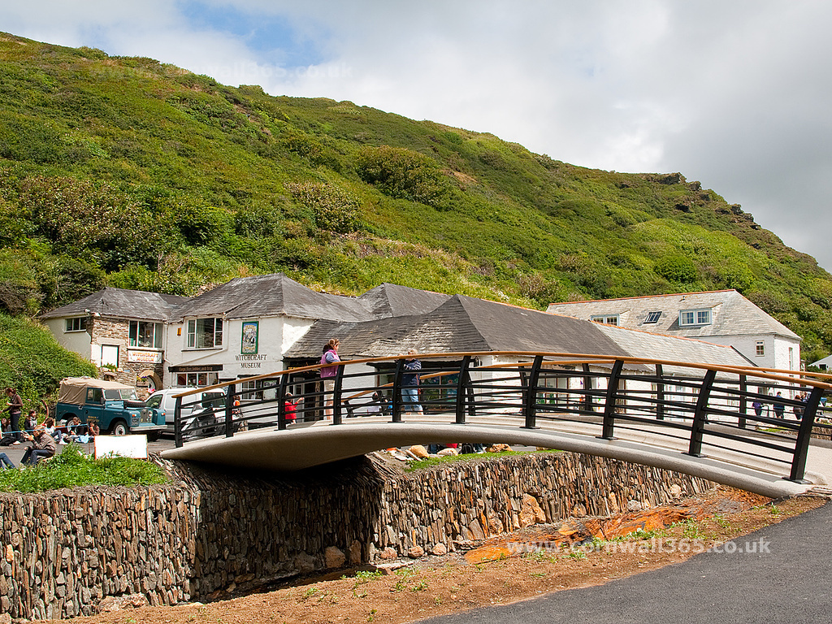
- A new Bridge had to be rebuilt that allowed a larger flow of water underneath to prevent the same problems experienced during the flood
- Increased tourism occurred as Boscastle got put on the map due to the increased publicity from the media

